**SOFTWARE REQUIREMENT SPECIFICATION**

**PROJECT TITLE:** Pharmacy Management

**STUDENT NAME:** Selvabharathi S

**STUDENT BITS ID:** 2022MT93556

**COURSE CODE:** SEZG518

|  |  |  |  |
| --- | --- | --- | --- |
| **Version**  **Number** | **Date** | **Author/Owner** | **Description of Change** |
| 1 | 13/Aug/2023 | Selvabharathi S | Problem statement, project features, software and hardware details, project plan |
| 2 | 15/Aug/2023 | Selvabharathi S | Conceptual Design: ER & Object Model |

1. **REQUIREMENT SPECIFICATION:**
2. **Problem Statement and Requirements Definition**

**1. Introduction**

**1.1 Purpose**

The purpose of this document is to define the requirements for the development of a Pharmacy Management System. This system aims to streamline the operations and management of a pharmacy, enhancing efficiency and customer service.

**1.2 Scope**

The Pharmacy Management System will encompass both a user-friendly web-based frontend and a backend system. It will facilitate tasks such as managing medicines, handling prescriptions, inventory management, customer records, and billing.

**1.3 Definitions, Acronyms, and Abbreviations**

**SRS:** Software Requirements Specification

**API:** Application Programming Interface

## 2. Problem Statement

Pharmacies often deal with a high volume of medicine stock, prescription records, and customer interactions. Manual management can lead to errors, inefficient inventory control, and slower service. The need is for a comprehensive system that automates and improves pharmacy management processes.

## 3. Proposed Solution

The Pharmacy Management System will provide a centralized platform for pharmacy staff to effectively manage medicines, prescriptions, inventory, and customer interactions. It will offer automation, real-time tracking, and reporting functionalities.

1. **Project features identified**

|  |  |  |
| --- | --- | --- |
| **Feature ID** | **Feature Name** | **Description** |
| F1 | User Authentication & Authorization | * Secure login and registration for pharmacy staff with role-based access control |
| F2 | Medicine Management | * Add, update and delete medicine details, including name, dosage, price, and availability. * Categorize medicines for easier n * avigation. |
| F3 | Prescription Handling | * Record and manage prescriptions from doctors, including patient information & prescribed medicines. * Track prescription history. |
| F4 | Inventory Management | * Real time tracking of medicine stock levels. * Automated alerts for low stock. * Manage incoming and outgoing stock. |
| F5 | Customer Records | * Maintain customer profiles with contact details, purchase history and prescriptions. |
| F6 | Billing and Invoicing | * Generate itemized bills for customers. * Apply discounts and calculate taxes automatically. |
| F7 | Reporting & Analytics | * Generate reports on inventroy levels, sales, profits, and customer trends. * Visualize data for informed decision-making. |
| F8 | Search and Filter | * Search and filter medicines, prescriptions, and customer records for easy retrieval. |
| F9 | User Friendly Interface | * Intuitive and responsive web-based frontend using Angular. * Backend powered by springboot for seamless data flow. |
| F10 | Public API Integration(Future Enhancement) | * Integration with external systems for e-prescriptions and insurance claims. |

1. **Software and hardware details**

|  |  |
| --- | --- |
| **Platform** | Web Application |
| **Frontend/ console** | Angular |
| **Backend/ server** | SpringBoot |
| **Database** | MySql |
| **Programming Language: Frontend** | JavaScript, TypeScript |
| **Backend/ server programming language** | Java |

1. **Project plan**

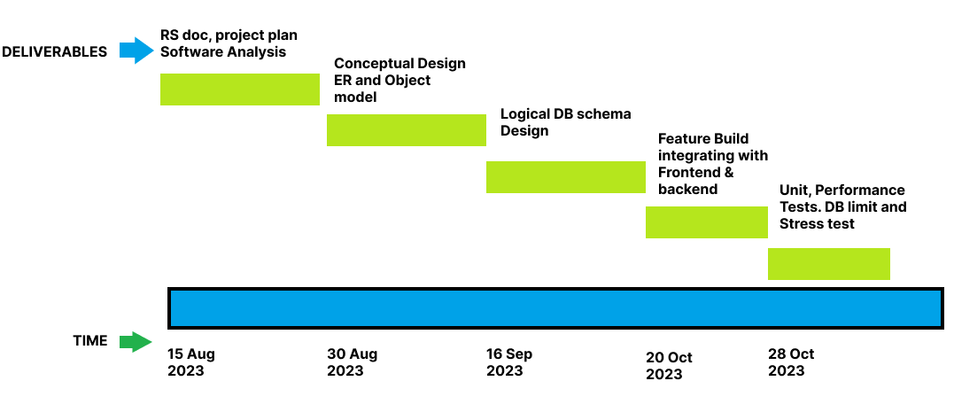

1. **Specify a Good drive link for sharing all your RS documents and future deliverables**

[**https://drive.google.com/drive/folders/1trN_aA2QxTTJupx67P-haQrt46W_23UD?usp=drive_link**](https://drive.google.com/drive/folders/1trN_aA2QxTTJupx67P-haQrt46W_23UD?usp=drive_link)

1. **Github url**

[selvabharathis/Pharmacy-Management-Portal: BITS Pilani SEM 2 DAA Project (github.com)](https://github.com/selvabharathis/Pharmacy-Management-Portal)

1. **CONCEPTUAL DESIGN:**
2. **Entity Relationship Model**

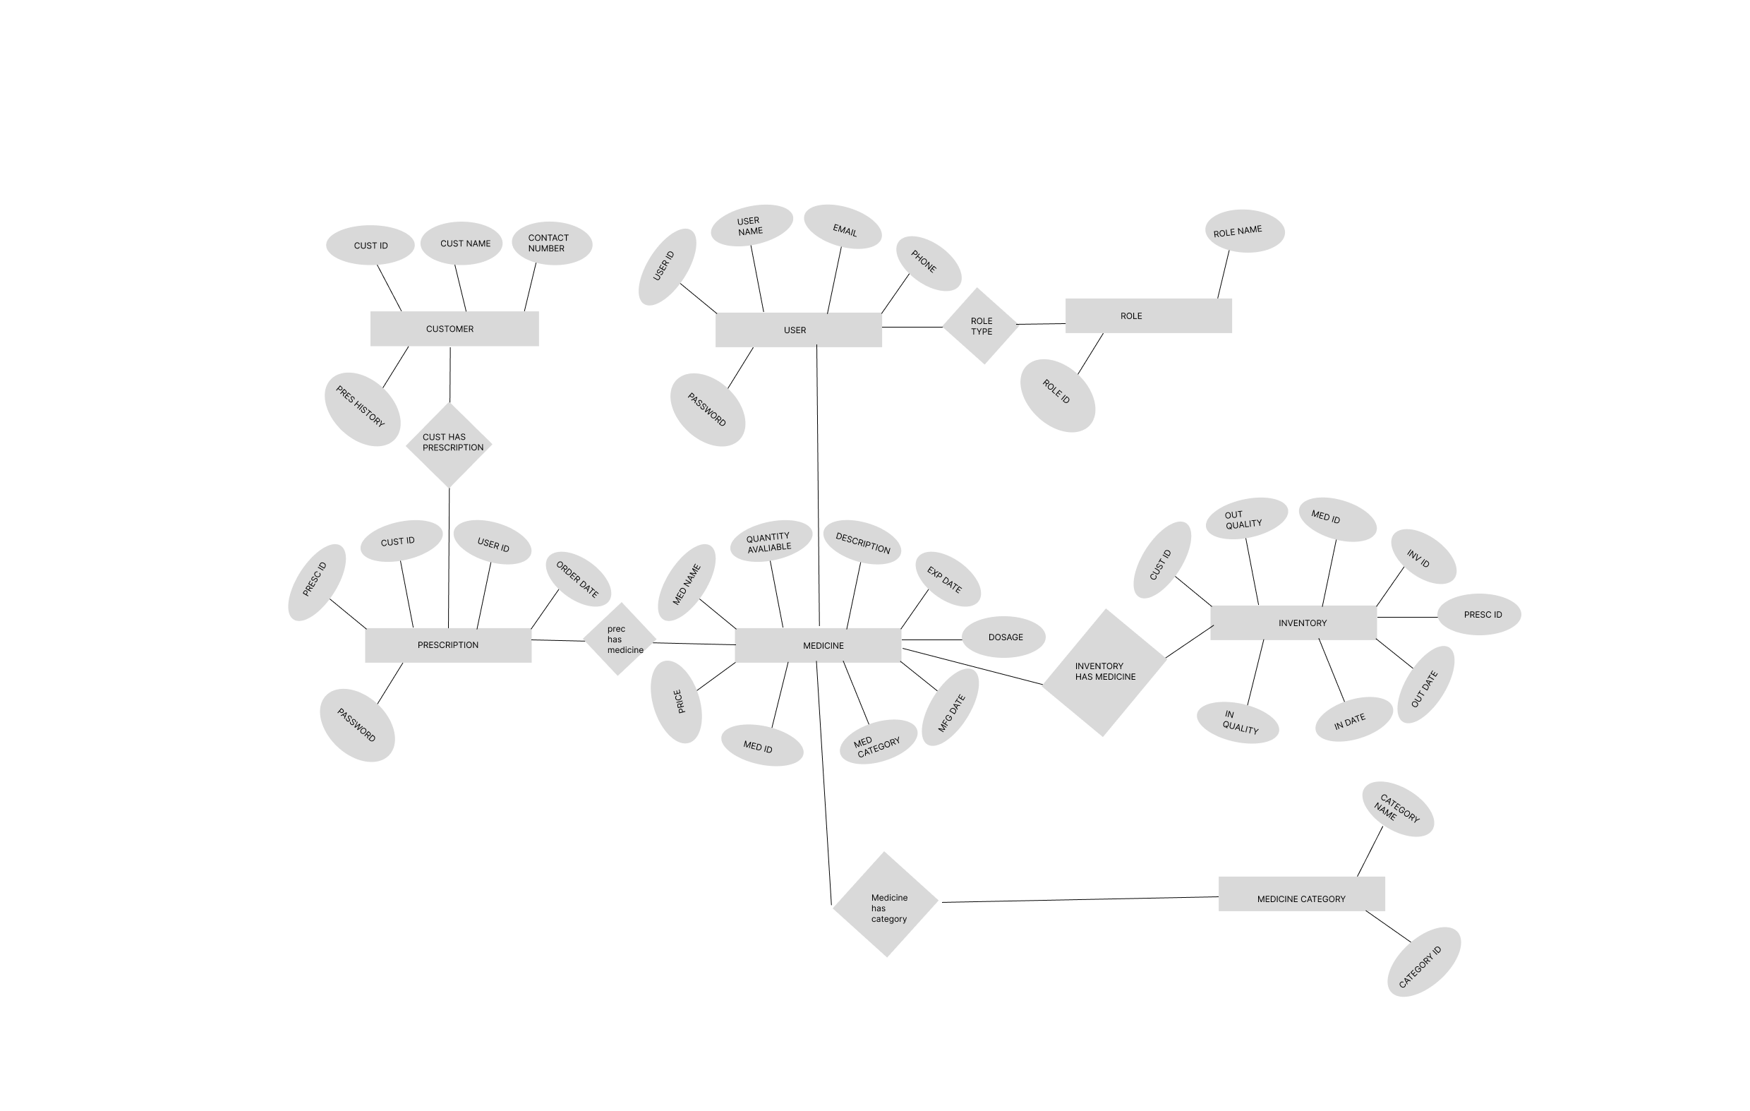

1. **Object Model**